Proposal Presentation Draft
PRESENTATION LINK:
15 mins
21.05.2026
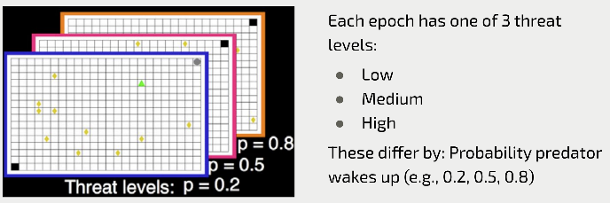
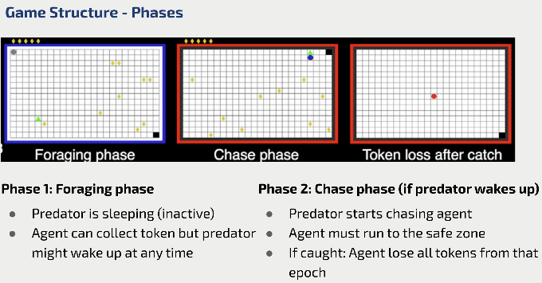

Outline of the problem
Within a 24x16 grid an agent and a threat (predator), and a safe place is placed alongside several tokens at random locations.
The predator could be inactive or active. If active, it has a different probability of waking up during each game run.
Agent's goal is to collect as many tokens as possible before the predator wakes up, when the threat becomes active, the agent should go to the safe zone to protect all the tokens collected, otherwise losing them all.
Our goal is to replicate this human-experimented game in a RL environment where we define a state space, an action space, and reward rules. Developing an RL agent would allow us to translate observed human behavior into mathematical models of decision-making under threat.

Describing two possible solutions
Draft ideas:
Different RL algorithms can test different theories of brain function
Representation-based models can simulate the spatial behavior linked to the hippocampus.
• Succession representation separates environmental layout (defined by transition dynamics) from the goals (rewards)
This might be able to mimic the brain's ability to adapt to a new threat in a familiar space without relearning the space's geometry.
We can also try altering agent's parameters, like reducing sensitivity to negative rewards. This can mean we replicate the reduced passive avoidance seen in patients with hippocampal lesions (like experiment 4)

Work plan
Pending

